Building a RAG Assistant with Snowflake Cortex Search
This quick guide covers how to set up a chatbot directly in Snowflake that lets you ask questions about your private PDF documents.

Introduction
Large Language Models (LLMs) are great at conversational tasks, but they often struggle with specific, private business data—sometimes even making up facts (hallucinating). This tutorial walks through building a Retrieval-Augmented Generation (RAG) assistant using Snowflake Cortex Search and Streamlit. By grounding the LLM in your actual private files, you get accurate, reliable answers without sending data outside your security perimeter.

Organizing Documents
Before querying your documents, you need to set up a place for them in Snowflake:

- Download Sample Files: Gather your PDF files, such as product manuals or technical docs.
- Set Up the Environment: Create a dedicated database named CC_QUICKSTART_CORTEX_SEARCH_DOCS and a schema named DATA.
- Create a Stage: Set up an internal stage named docs with a directory table enabled so Snowflake can track incoming files.
- Verify Uploads: Upload your PDFs to the stage and run a quick query on the directory table to make sure all files are present and recognized.

Pre-processing Documents
Raw PDFs need to be parsed and chunked so the search engine and LLM can digest them easily:

- Extracting Content: Use SNOWFLAKE.CORTEX.PARSE_DOCUMENT in LAYOUT mode. This pulls out readable text while preserving the structural layout of the document.
- Creating a Storage Table: Build a target table called DOCS_CHUNKS_TABLE to store the processed document sections.
- Chunking Text: Pass the extracted text through SNOWFLAKE.CORTEX.SPLIT_TEXT_RECURSIVE_CHARACTER to break large texts down into smaller, bite-sized pieces optimal for LLM context windows.
- Categorizing: Run CLASSIFY_TEXT to automatically label document chunks with relevant tags (such as 'Bike' or 'Snow'). Save these categories to your chunks table to enable precise filtering later.

Creating Cortex Search Service
Setting up search in Snowflake is simple and doesn't require managing external vector databases:

- Define the Search Service: Create a CORTEX SEARCH SERVICE pointed at the chunk text column in your table.
- Enable Metadata Filtering: Configure the service to use the category attribute as a filter.
- No Manual Embeddings: Snowflake automatically handles vector generation and indexing behind the scenes—no manual embedding pipelines or vector stores required.

Building the Chat UI
The final phase turns your backend setup into an interactive web app:

- Streamlit in Snowflake (SiS): Write a clean user interface using Streamlit directly inside Snowflake. This keeps your entire stack secure and hosted in one environment.
- Interactive Querying: The UI lets users select categories, ask questions, and display grounded answers alongside source references in real time.

Code Snippets
Setup:
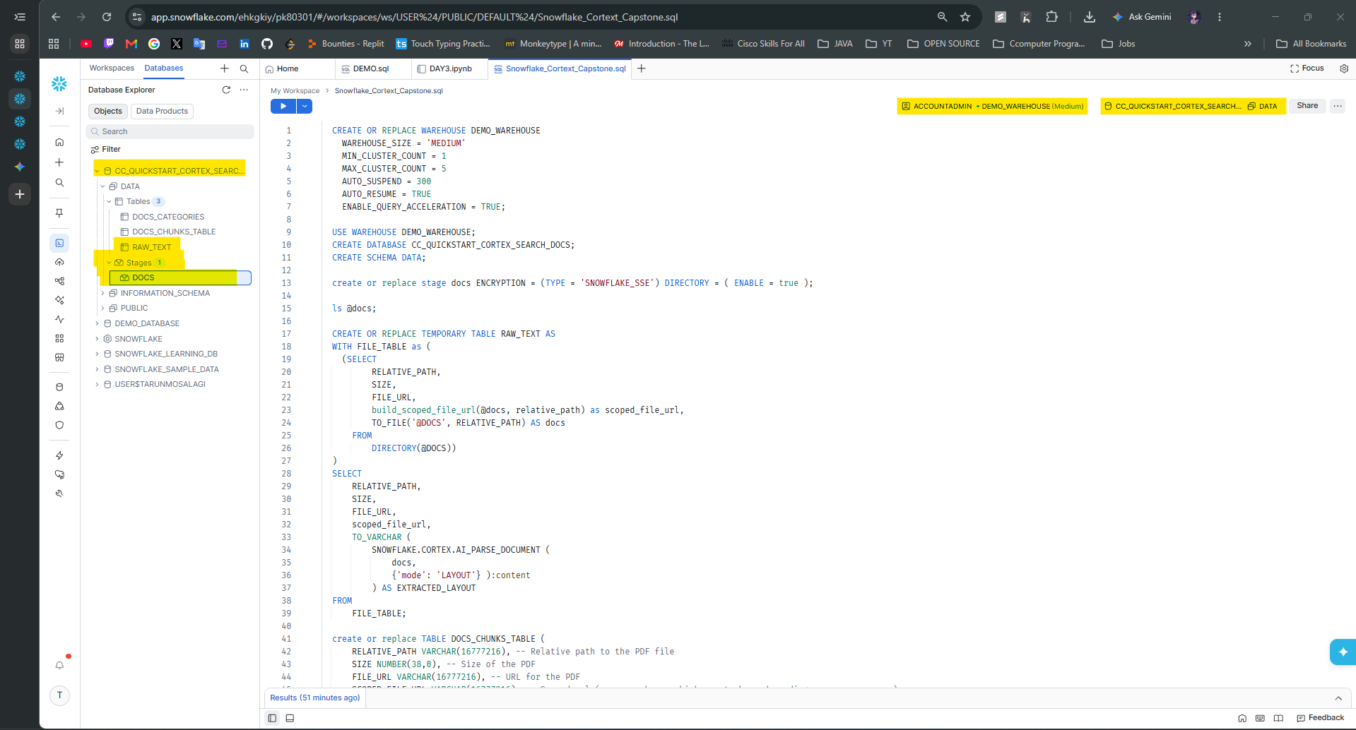

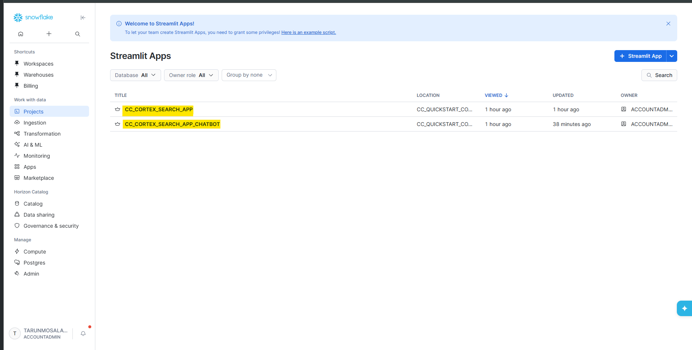

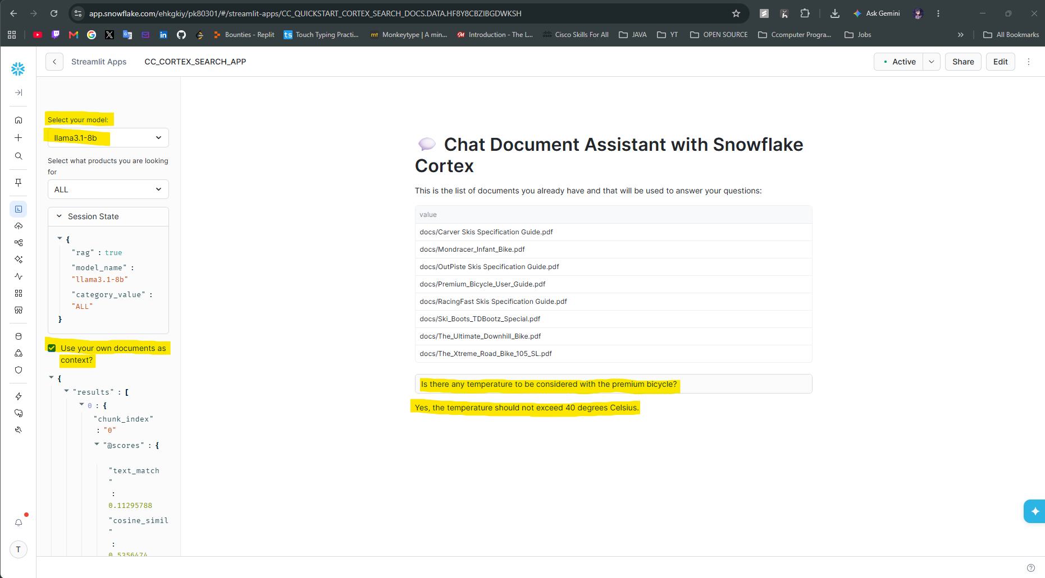

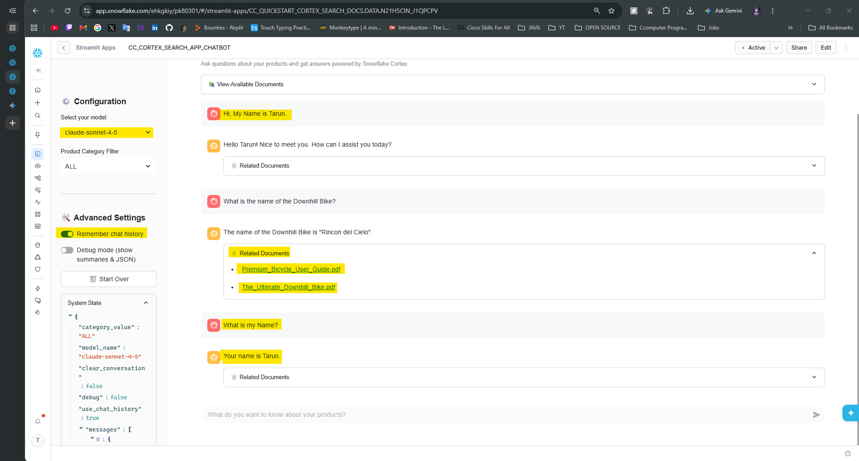

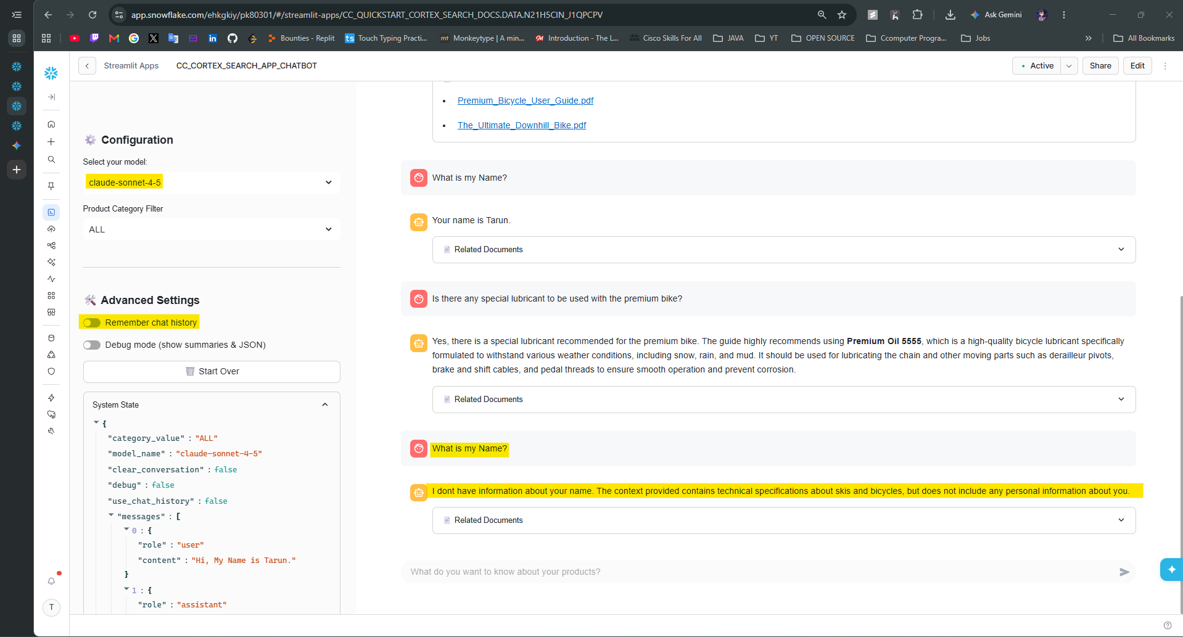

All Codes are uploaded in the GitHub Repository.

